Heaven's Light is Our Guide
Rajshahi University of Engineering & Technology

Department of Electrical & Computer Engineering
Course Title: Digital Techniques Sessional
Course No.: ECE-2112
Lab No: 03

Date of Submission: 23 August, 2026
Submitted To  MST. Mazeda Noor Tasnim  Lecturer,  Department of Electrical & Computer Engineering, RUET | Submitted By  Showmee Ahmed  Roll: 2410037

Simulation of Logic Circuits from Boolean Expressions Using Logisim
This report presents the simplification of five Boolean expressions using the laws and theorems of Boolean algebra, followed by the design and simulation of the corresponding logic circuit for each simplified expression in Logisim.
Objectives
- To simplify each given Boolean expression by applying the relevant Boolean algebra laws and theorems.
- To verify each simplification step by explicitly stating the law used at every stage.
- To design and simulate the logic circuit corresponding to each simplified expression in Logisim.
- To compare the complexity of the original and the simplified expressions in terms of gate count and number of literals.
Theory
Boolean algebra is a mathematical framework used to analyze and simplify digital logic circuits. A Boolean variable can take on only one of two possible values, 0 (LOW) or 1 (HIGH). The three fundamental operations of Boolean algebra are the AND operation (denoted by · or juxtaposition), the OR operation (denoted by +), and the NOT or complement operation (denoted by an overbar).
The laws applied throughout this report include the Commutative, Associative, Distributive, Absorption, Complement and Idempotent laws, De Morgan's theorems, and the Consensus theorem. Simplifying a Boolean expression before implementation reduces the number of gates, inputs and interconnections required, resulting in a circuit that is cheaper to build, faster in operation and easier to troubleshoot, while still producing an output identical to that of the original expression for every possible input combination.

Problem 1: Simplification and Logic Circuit Implementation of the Boolean Expression
F = AB + B̅C + AC + A̅BD̅
Objective
- To simplify the given Boolean expression using Boolean algebra laws.
- To verify the simplified expression algebraically.
- To design and simulate the corresponding logic circuit in Logisim.
- To compare the original and simplified expressions and confirm that they are logically equivalent.
Simplification
F = AB + B̅C + AC + A̅BD̅
Since AC is the consensus term of AB and B̅C (taken over the variable B), it is redundant and can be eliminated:
F = AB + B̅C + A̅BD̅ [Consensus theorem: AB + B̅C + AC = AB + B̅C]
Grouping the terms containing B and factoring:
F = B̅C + B(A + A̅D̅)
= B̅C + B(A + D̅) [Absorption law: X + X̅Y = X + Y]
= B̅C + AB + BD̅
F = AB + BD̅ + B̅C
This is the fully minimized SOP form; no further reduction is possible, since the remaining terms share no complementary pair of literals.
Simulated Circuit (Simplified Expression)
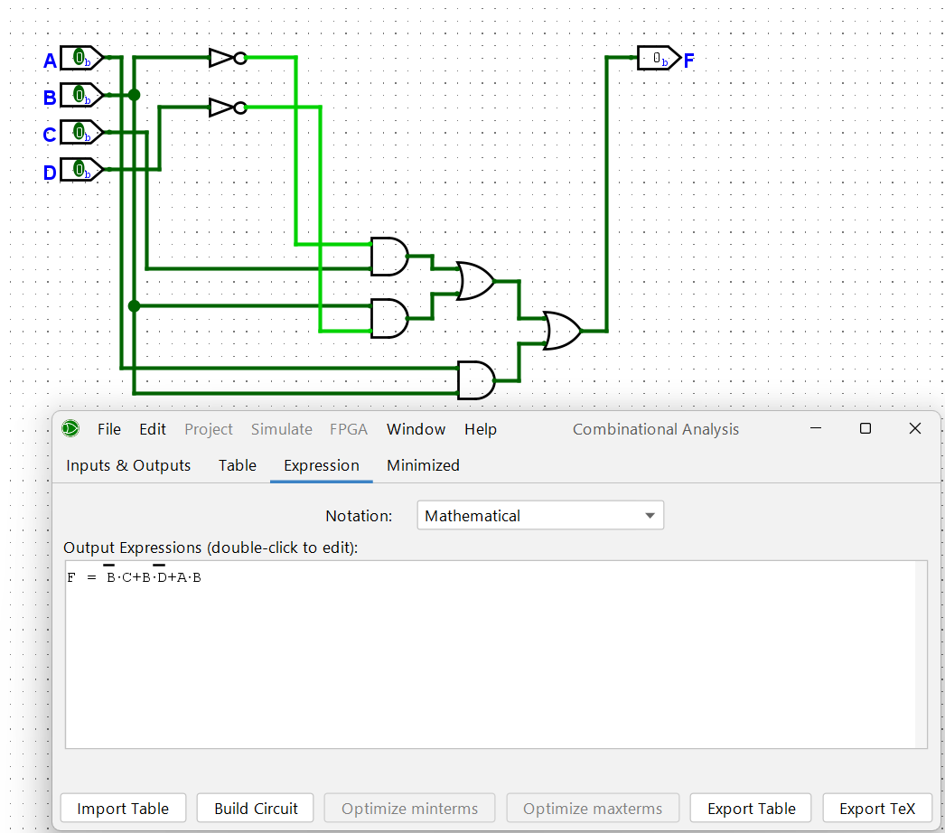
Figure 1: Logic circuit for F = AB + BD̅ + B̅C
Discussion
The original expression F = AB + B̅C + AC + A̅BD̅ was reduced using the Consensus theorem followed by the Absorption law. The consensus term AC, formed from AB and B̅C, was first identified and removed. The remaining term A̅BD̅ was then combined with AB through absorption, which produced the simpler term BD̅ in place of the original four-literal term. The resulting expression, F = AB + BD̅ + B̅C, consists of only three two-literal product terms, a considerable reduction from the original four-term expression.
Conclusion
The Boolean expression F = AB + B̅C + AC + A̅BD̅ was successfully simplified to F = AB + BD̅ + B̅C using the Consensus theorem and the Absorption law. The simplified circuit requires fewer AND gates and fewer input connections than the original, while remaining logically equivalent for every combination of A, B, C and D.

Problem 2: Simplification and Logic Circuit Implementation of the Boolean Expression
F = [(A̅+B)(C+D̅)]′ · [AB̅ + CD]
Objective
- To simplify the given Boolean expression using Boolean algebra laws.
- To verify the simplified expression algebraically.
- To design and simulate the corresponding logic circuit in Logisim.
- To compare the original and simplified expressions and confirm that they are logically equivalent.
Simplification
F = [(A̅+B)(C+D̅)]′ · [AB̅ + CD]
Applying De Morgan's law to the first bracket:
[(A̅+B)(C+D̅)]′ = (A̅+B)′ + (C+D̅)′ = AB̅ + C̅D
Substituting back into the original expression and multiplying out the two factors:
F = (AB̅ + C̅D) · (AB̅ + CD)
= AB̅·AB̅ + AB̅·CD + C̅D·AB̅ + C̅D·CD
= AB̅ + AB̅CD + AB̅C̅D + 0 [Idempotent: AB̅·AB̅ = AB̅; C̅D·CD = 0, since C̅·C = 0]
= AB̅(1 + CD + C̅D)
F = AB̅ [1 + X = 1]
AB̅ is a common factor of every term in the product, so the whole expression collapses to it once the redundant terms are absorbed.
Simulated Circuit (Simplified Expression)
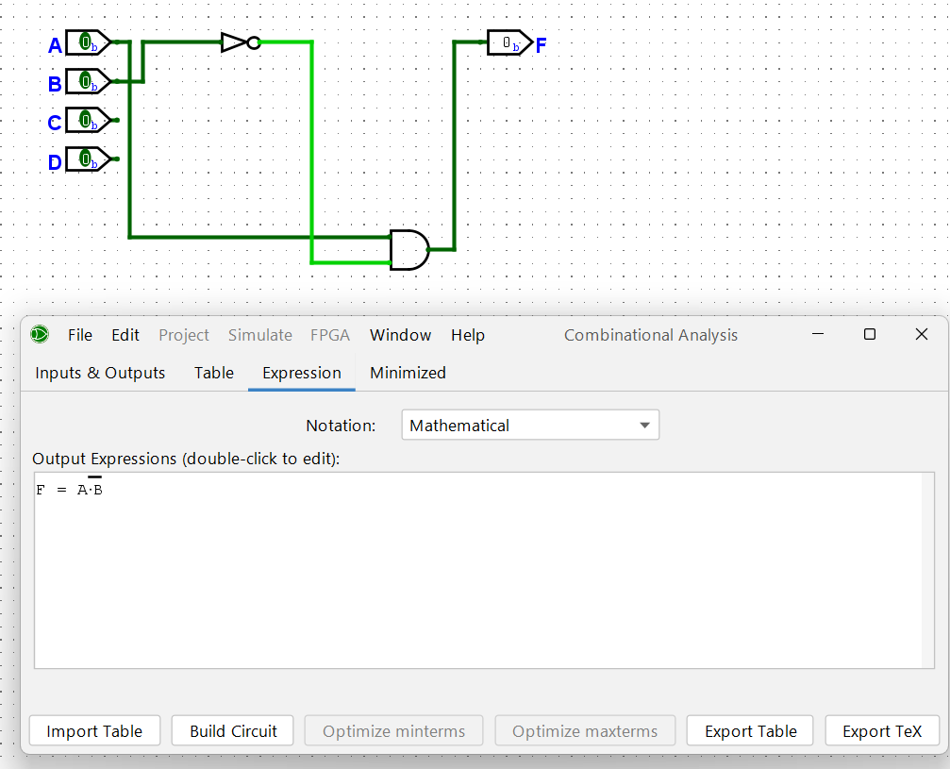
Figure 2: Logic circuit for F = AB̅
Discussion
In this problem, De Morgan's law was applied to the complemented bracket [(A̅+B)(C+D̅)]′, converting it into AB̅ + C̅D. Multiplying this out against the second bracket, AB̅ + CD, shows that AB̅ is common to both factors: every product term either reduces to AB̅ directly or contains AB̅ as a factor, while the one term without AB̅ (C̅D·CD) vanishes because C and C̅ cannot both be 1. The circuit therefore reduces to the single term AB̅, requiring only one AND gate and one inverter.
Conclusion
The expression F = [(A̅+B)(C+D̅)]′ · [AB̅ + CD] was simplified to F = AB̅ using De Morgan's law, the Distributive law, and the Idempotent law. Although the two bracketed factors are not equal expressions, AB̅ is common to both, and multiplying them out shows that every other term is absorbed or vanishes, leaving only AB̅. This result demonstrates that a full algebraic expansion can reveal simplifications that are not obvious from the original expression alone.

Problem 3: Simplification and Logic Circuit Implementation of the Boolean Expression
F = ABCD + AB̅CD + A̅BCD + ABC̅D + ABCD̅
Objective
- To simplify the given Boolean expression using Boolean algebra laws.
- To verify the simplified expression algebraically.
- To design and simulate the corresponding logic circuit in Logisim.
- To compare the original and simplified expressions and confirm that they are logically equivalent.
Simplification
F = ABCD + AB̅CD + A̅BCD + ABC̅D + ABCD̅
The five minterms, expressed in the order ABCD, are as follows:
ABCD = 1111 (m15), AB̅CD = 1011 (m11), A̅BCD = 0111 (m7), ABC̅D = 1101 (m13), ABCD̅ = 1110 (m14)
Each of m11, m7, m13 and m14 differs from m15 in exactly one bit position, so each can be paired directly with m15 using the Combining law (XY + XY̅ = X):
m15 & m11 (differ in B) → ACD; m15 & m7 (differ in A) → BCD; m15 & m13 (differ in C) → ABD; m15 & m14 (differ in D) → ABC
Since each of m11, m7, m13 and m14 is covered by only one implicant, all four terms are essential prime implicants:
F = ABC + ABD + ACD + BCD
This simplified expression is recognizable as the 3-out-of-4 majority function — the output is 1 whenever at least three of the four inputs are 1.
Simulated Circuit (Simplified Expression)
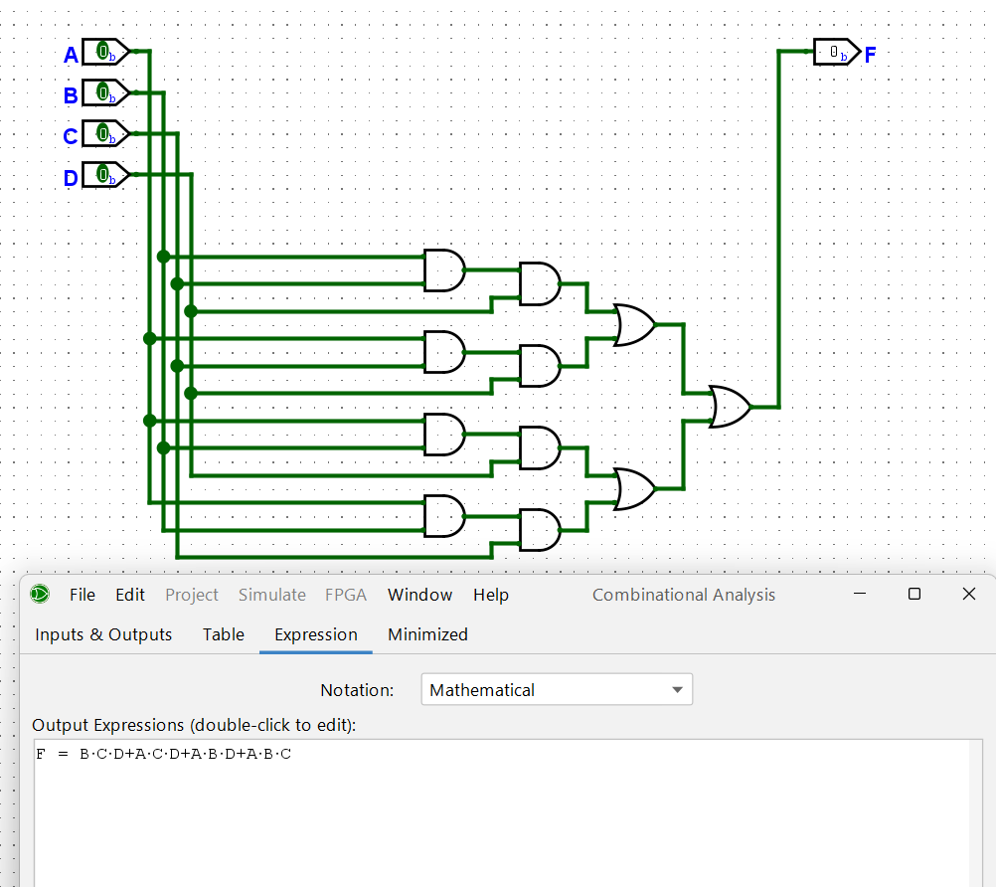
Figure 3: Logic circuit for F = ABC + ABD + ACD + BCD
Discussion
The given SOP expression consists of five four-literal minterms. Since four of the five minterms differ from the fifth (ABCD) in exactly one bit position, each such pair could be combined into a three-literal term using the Combining law. The four resulting terms — ABC, ABD, ACD and BCD — are all essential prime implicants, since each is the only term covering one of the original minterms. The simplified expression is readily identified as a four-variable majority function.
Conclusion
The expression F = ABCD + AB̅CD + A̅BCD + ABC̅D + ABCD̅ was successfully minimized to F = ABC + ABD + ACD + BCD. The simplified circuit requires only four 3-input AND gates and a single 4-input OR gate, compared with five 4-input AND gates and a 5-input OR gate in the original implementation, reducing both the gate count and the total number of input literals.

Problem 4: Simplification and Logic Circuit Implementation of the Boolean Expression
F = (A+B+C+D)(A+B+C̅)(A+B̅+C)(A̅+B+C)
Objective
- To simplify the given Boolean expression using Boolean algebra laws.
- To verify the simplified expression algebraically.
- To design and simulate the corresponding logic circuit in Logisim.
- To compare the original and simplified expressions and confirm that they are logically equivalent.
Simplification
F = (A+B+C+D)(A+B+C̅)(A+B̅+C)(A̅+B+C)
No two of the four factors are identical, so the Idempotent law does not directly apply; instead, the factors are combined pairwise using the identity (X+P)(X+Q) = X+PQ. Grouping the first two factors around the common term X = A+B:
(A+B+C+D)(A+B+C̅) = (A+B) + (C+D)C̅ = A+B+C̅D
Next, combining this result with the third factor around the common term X = A:
(A+B+C̅D)(A+B̅+C) = A + (B+C̅D)(B̅+C) = A + BC + B̅C̅D
Finally, multiplying by the remaining factor (A̅+B+C) and expanding:
F = (A + BC + B̅C̅D)(A̅+B+C)
= AB + AC + A̅BC + BC + BC + A̅B̅C̅D
= AB + AC + BC + A̅B̅C̅D [A̅BC + BC = BC, by absorption]
F = A̅B̅C̅D + AB + AC + BC
This four-term SOP expression was also verified directly against the original expression for several input combinations — for example, A=1, B=0, C=1, D=0 gives F=1 in both forms — confirming the simplification is correct. No further reduction is possible.
Simulated Circuit (Simplified Expression)
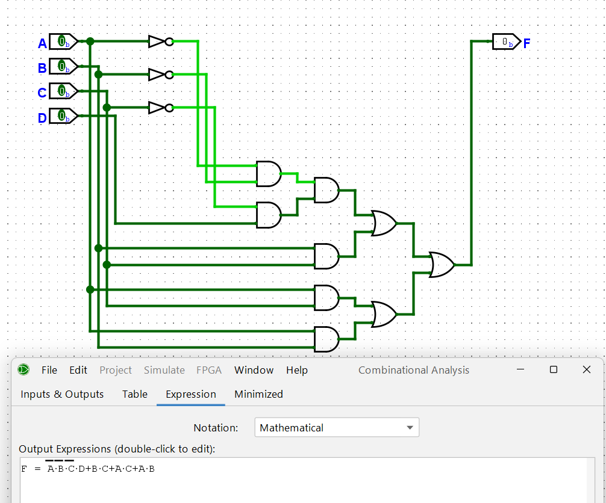
Figure 4: Logic circuit for F = A̅B̅C̅D + BC + AC + AB
Discussion
The four POS factors share no common repeated term, so the reduction was carried out by repeatedly applying the identity (X+P)(X+Q) = X+PQ. Combining the first two factors around A+B produced a C̅D term; combining that result with the third factor around A introduced the pair BC and B̅C̅D; and multiplying by the final factor caused the duplicate BC terms to absorb into a single BC while all other cross terms reduced cleanly. The final expression, F = A̅B̅C̅D + AB + AC + BC, is a compact four-term SOP that is considerably simpler than the original four-factor, twelve-literal POS expression.
Conclusion
The expression (A+B+C+D)(A+B+C̅)(A+B̅+C)(A̅+B+C) was successfully simplified to F = A̅B̅C̅D + AB + AC + BC by repeatedly applying the identity (X+P)(X+Q) = X+PQ. The simplified circuit requires only three 2-input AND gates, one 4-input AND gate, one 4-input OR gate and three inverters — a significant reduction from the original four-factor POS structure.

Problem 5: Simplification and Logic Circuit Implementation of the Boolean Expression
F = [A + B̅(C+D)] · [A̅ + B(C̅+D̅)]
Objective
- To simplify the given Boolean expression using Boolean algebra laws.
- To verify the simplified expression algebraically.
- To design and simulate the corresponding logic circuit in Logisim.
- To compare the original and simplified expressions and confirm that they are logically equivalent.
Simplification
F = [A + B̅(C+D)] · [A̅ + B(C̅+D̅)]
Let X = A, P = B̅(C+D), and Q = B(C̅+D̅). The expression then has the form (X+P)(X̅+Q), which by the Consensus theorem simplifies directly to XQ + X̅P, since the consensus term PQ is redundant:
F = (X+P)(X̅+Q) = XQ + X̅P
= A·B(C̅+D̅) + A̅·B̅(C+D)
= ABC̅ + ABD̅ + A̅B̅C + A̅B̅D
F = ABC̅ + ABD̅ + A̅B̅C + A̅B̅D
This result can equivalently be written in the factored form F = AB(C̅+D̅) + A̅B̅(C+D), which is convenient for implementation and was verified against the original expression at several input points.
Simulated Circuit (Simplified Expression)
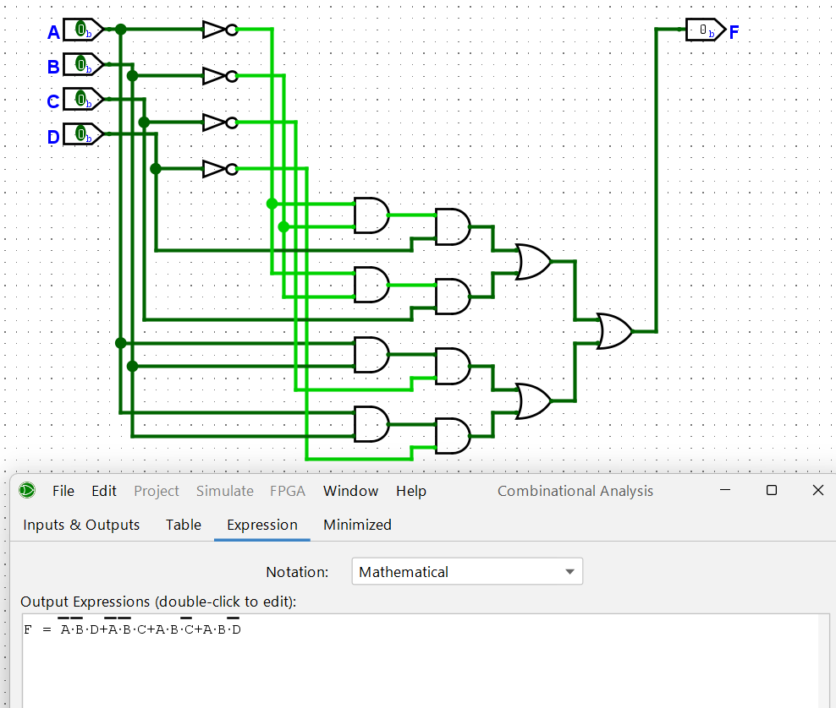
Figure 5: Logic circuit for F = ABC̅ + ABD̅ + A̅B̅C + A̅B̅D
Discussion
The two bracketed factors have the general form (X+P)(X̅+Q), which the Consensus theorem simplifies directly to XQ + X̅P, the consensus term PQ being redundant. Substituting X = A, P = B̅(C+D) and Q = B(C̅+D̅) and expanding yields a four-term SOP expression. Functionally, the resulting circuit behaves as an equality-type comparator between B and (C or D), gated by the variable A.
Conclusion
The expression F = [A+B̅(C+D)]·[A̅+B(C̅+D̅)] was simplified to F = ABC̅ + ABD̅ + A̅B̅C + A̅B̅D using the Consensus theorem, yielding a direct SOP realization that avoids the nested AND-OR-AND structure of the original expression.

